Chapter 12, Problem 40.

For the three-phase circuit in Fig. 12.59, find the average power absorbed by the delta-connected load with Z_{Δ} = 21 + j24 Ω.

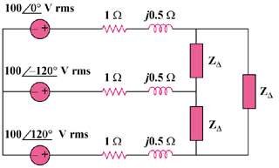

Figure 12.59
For Prob. 12.40.

